70.03.28
From James Turner
Turner letterbook, Anglican Diocesan Registry, Armidale, NSW.

Grafton, N.S.W.
March 28, 1870.
Dear Sir,
I beg to thank you for the number of your Fragmenta which you have so kindly forwarded to me. I believe that there are a good many more published which I should like to have if I could procure them at a reasonable cost. Would you be so kind as to write me word what the cost would be for a complete set? — I don't know whether any such thing has ever been done but it seems to me that it would facilitate the recognizing and description of plants if we could have sheets (printed) with hints to observers upon them for I think that then persons (some) with limited botanical knowledge would often be stimulated to observe plants and to improve their powers of observation as I should very much like to do, being very fond of everything in nature as we call it, but especially flowers and plants, and only possessing a very limited acquaintance with flowers — When according to the best books I have settled what is to my mind the class of a plant, having no catalogue it seems so discouraging to endeavour to do more than say "Oh this is some kind of lily" or "some kind of some thing else". As an example of my difficulty I will tell you that recently at the Clarence Heads in a dried swamp I found a plant of considerable beauty, I conceive some kind of "lilium"; the colour of the plant is a deep orange striated with red and the edges of the corolla are nearly yellow pure — let me try to sketch it. it has grassy leaves and the stem is markedly 'zigzag' as exaggerated —
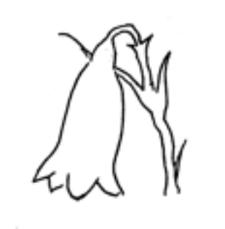 Probably if I had your F. Phy. I could have identified it — as it was I could go no further than 'Lilium'. There is an Ipomoea which grows there with a large leaf 'cordate' I should say with a peculiar habit of folding itself inwards roughly thus so that it looks like a sort of book (half open).
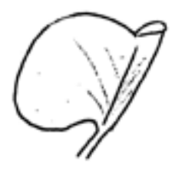There is also, besides no doubt many more plants which I never saw, a very fine kind of Gnaphalium — You may be sure that any kind of plant that I observe likely in my mind to be new will be forwarded to you henceforth. I found once down in a very rough hollow on a rock a very beautiful little alga or fern I could not quite be sure, but I think now that it was an alga, filmy as goldbeater skin and as transparent and very minute. Unhappily I had no way of preserving it. I found it under one of the ranges dividing the Richmond and Clarence districts.
I have heard that there was some probability of our losing your services as the Govt. of Victoria was inclined to withdraw the grant out of which your income comes. I trust that there is spirit enough for the love of science amongst the members of these colonies somewhere to enable us to have the honour of retaining your services — speaking for myself I should gladly guarantee my fair share of a yearly subscription for such a purpose should the Government withdraw. You will forgive me speaking on such a subject so freely, my only desire being that if such a scheme were proposed I should feel pleasure in being allowed to help as far as I could for I consider that Museums and suchlike places are when properly conducted and used, weapons of religion to every humbleminded person places of constant remembrance of God's love and merciful Providence over us and all his works.
Pray accept my thanks for your trouble about the ferns and
Believe me
Yours very truly
James F. Turner
(Bishop of Grafton & Armidale)

To: Dr Fredk. Mueller PhD &c.
Melbourne.

Lilium
Gnaphalium
Ipomoea

The text given here is based on a transcription prepared for Dr Lionel Gilbert in the 1960s from a letterbook of Turner's at the Anglican Diocesan Registry, Armidale, NSW, and subsequently reviewed by him. However, the relevant letterbook has since been misplaced. The transcription is now in the library of the Royal Botanic Gardens Melbourne, in the Mueller Project's file of correspondence with Dr Gilbert.
Presumably B70.01.01. No set of the Fragmenta has been found among Turner's papers.
70-03-28_image02.jpg.
70-03-28_image01.jpg.
Fragmenta phytographiae australiae.
70-03-28_image03.jpg.

